**OSH Authorities – Denmark**

Source: <https://oshwiki.eu/wiki/OSH_system_at_national_level_-_Denmark>

* OSH Infrastructure

Scheme:

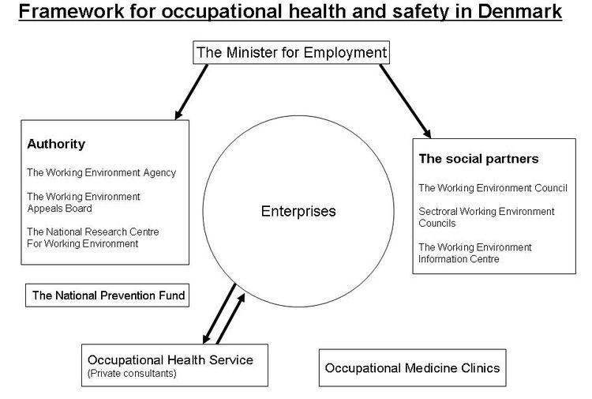

* OSH Authorities

|  |  |
| --- | --- |
| Name of the Authority | The Danish Working Environment Authority (DWEA) |
| Link | <http://engelsk.arbejdstilsynet.dk/en> |
| Short abstract | The Danish Working Environment Authority (DWEA / Danish: Arbejdstilsynet - abbreviated AT) is an agency that works under the auspices of the Ministry of Employment at national and regional level, contributing to the creation of safe working conditions. It is empowered with supervision and enforcement rights, which are commonly designated to labour inspectorates in other countries. The three main fields of activity are:  Carrying out inspections in companies.  Drawing up OSH rules.  Providing OSH information.  The DWEA has the authority to penalise companies which do not comply with the working environment rules. They can also issue administrative fines for clear violations of the Working Environment Act, and in cases of extreme danger, they may also order work to be suspended.  The DWEA is managed by an Administrative Board made up of the Director-General, 2 Deputy Directors and three Inspection Directors. The headquarters and two of the four centres are located in Copenhagen. The regional Inspection Centres with approximately 100 employees each.  The Working Environment Authority is responsible for the inspection of OSH conditions in companies. This includes verifying that a written evaluation has been carried out, specific to that particular workplace. This is equivalent to a risk assessment in the terminology of the EU-OSH Directives.  If the company’s working environment and the health and safety policies are found to be in good order, no reason is seen for a new inspection in the near future. However, if problems are found, the company will be visited within a period of 12-18 months. |
| Link to OSH wiki | <https://oshwiki.eu/wiki/OSH_system_at_national_level_-_Denmark> |

* Compensation and insurance bodies

|  |  |
| --- | --- |
| Name of the Body | Labour Market Insurance AES |
| Link | <https://www.aes.dk/> |
| Short abstract | Labour Market Insurance (Arbejdsmarkedets Erhvervssikring – AES) is an independent institution administrated by the Danish Labour Market Supplementary Pension Scheme (Arbejdsmarkedets Tillægspension – ATP).  AES follows the applicable regulations in determining whether an injury or illness can be classified as an industrial injury. When an injury or illness can be recognised as an industrial injury, AES then decides the amount of compensation payable.  AES funds and pays compensation for recognised occupational diseases. It is mandatory for all private and public sector employers in Denmark to contribute to AES. |
| Link to OSH wiki | <https://oshwiki.eu/wiki/OSH_system_at_national_level_-_Denmark> |

* Research Institutes

|  |  |
| --- | --- |
| Name of the Institute | The National Research Centre for the Working Environment (NRCWE) |
| Link | <http://www.arbejdsmiljoforskning.dk/da> |
| Short abstract | (Det Nationale Forskningscenter for Arbejdsmiljø, NFA)  NRCWE is a government research institute under the auspices of the Ministry of Employment. The mission of the NRCWE is to generate new research based knowledge about occupational safety and health in order to contribute to healthy and stimulating working conditions in accordance with the demands and needs of society, enterprises and the working environment system. The NRCWE provides research based knowledge and counselling to the Ministry of Employment, including the Danish Working Environment Authority. The NRCWE disseminates research based knowledge to the social partners, enterprises and working environment counsellors, contributes to higher education at the universities, and serves as an entrance to general information about working environment issues through the Working Environment Information Centre.  The following are the current strategic research areas of the NRCWE:   * Psychosocial working environment * Musculoskeletal disorders * Nano safety * Work accidents and safety culture |
| Link to OSH wiki | <https://oshwiki.eu/wiki/OSH_system_at_national_level_-_Denmark> |

|  |  |
| --- | --- |
| Name of the Institute | The Danish Working Environment Research Fund |
| Link | <http://engelsk.arbejdstilsynet.dk/en/research/arbejdsmiljoforskningsfonden> |
| Short abstract | The objective ofthe Danish Working Environment Research Fund is to strengthen Danish working environment research through the adoption of a research strategy and allocation of funds based on the prioritized themes laid out in the research strategy. Presently, these themes are:   * Work accidents * Work accidents * Psychological working environment * Musculoskeletal disorders * OSH instruments The Fund supports research and development in occupational safety and health with the purpose of preventing and reducing working environment problems leading to mental and physical health problems and early retirement from the labour market. The Fund also supports reviews of occupational diseases on basis of specific calls for applications. From 2003 to 2016, the Fund has approved research grants for 284 projects totaling DKK 758,7 million. The Danish Working Environment Research Fund invites applications twice a year with deadlines around 1 March and 1 September. |
| Link to OSH wiki | <https://oshwiki.eu/wiki/OSH_system_at_national_level_-_Denmark> |

* Prevention services

|  |  |
| --- | --- |
| Name of the Service | NONE |
| Link |  |
| Short abstract | The Danish Occupational Health Service system was modified by the government in the Working Environment Reform in 2005. The previous mandatory system that required enterprises to seek advice from the Occupational Health Service was replaced with a system based on a combination of market-based consultancy and Working Environment Service authorised consultants.  If a company is found to have an OSH problem, the Danish Working Environment Authority can issue a consultancy notice, ordering the company to seek advice from an authorised health and safety consultant, who must help solve the problem, and also reinforce preventive OSH activities. |
| Link to OSH wiki | <https://oshwiki.eu/wiki/OSH_system_at_national_level_-_Denmark> |

* Other services

|  |  |
| --- | --- |
| Name of the body | The Working Environment Council (Arbejdsmiljørådet) |
| Link | https://www.amr.dk/ |
| Short abstract | The social partners are represented in the Working Environment Council, which advises the Minister of Employment on overall questions regarding the prioritization of OSH efforts. The Working Environment Council discuss questions which it finds important for OSH and comments on this to the Minister of Employment. The Council comments on and proposes new laws and rules. The Council also comments rules before they are established. |
| Link to OSH wiki | <https://oshwiki.eu/wiki/OSH_system_at_national_level_-_Denmark> |

|  |  |
| --- | --- |
| Name of the Association | The Danish Association of Occupational Health and Safety Consultants |
| Link | The Danish Association of Occupational Health and Safety Consultants is the trade association for all occupational health and safety professionals. That is, authorised occupational health and safety professionals, other occupational health and safety consultants, and internal divisions engaged in occupational health and safety.  The Association was founded on November 29th 1993 in Horsens, Denmark, and called the Association of Occupational Health. In 2006, it changed its name into the Danish Association of Occupational Health and Safety Consultants as a consequence of the phasing out of the public occupational health services. |
| Short abstract | <http://www.arbejdsmiljoraadgiverne.dk/1-55-english-version.html> |
| Link to OSH wiki | <https://oshwiki.eu/wiki/OSH_system_at_national_level_-_Denmark> |

|  |  |
| --- | --- |
| Name of the Association | Association of OSH Professionals (Sammenslutningen af Sikker-hedsledere i Danmark (SSID) |
| Link | <http://arbejdsmiljonet.dk> |
| Short abstract | The purpose of the association is:   * to ensure that occupational health professionals gain high academic knowledge * to stimulate method development * to help exchange experiences * to arrange meetings, conferences and courses * to cooperate with authorities, organizations and associations |
| Link to OSH wiki | <https://oshwiki.eu/wiki/OSH_system_at_national_level_-_Denmark> |

* Standardization Bodies

|  |  |
| --- | --- |
| Name of the Authority | Danish Standards (Dansk Standard) |
| Link | https://www.ds.dk/en |
| Short abstract | Danish standards develops and publishes standards, provides trainings and offers consultancy. Certification or accreditation by a recognised body are used to ensure that national standards correspond with training. |
| Link to OSH wiki | <https://oshwiki.eu/wiki/OSH_system_at_national_level_-_Denmark> |